Direct Deposit Agreement Form

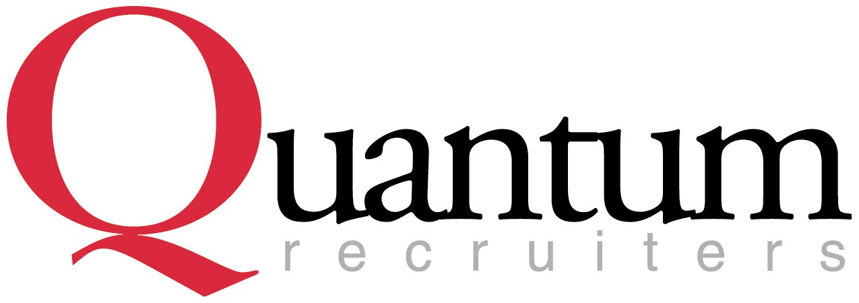

Authorization Agreement
I hereby authorize Quantum Recruiters to initiate automatic deposits to my account at the financial institution named below. I also authorize Quantum Recruiters to make withdrawals from this account in the event that a credit entry is made in error. Further, I agree not to hold Quantum Recruiters responsible for any delay or loss of funds due to incorrect or incomplete information supplied by me or by my financial institution or due to an error on the part of my financial institution in depositing funds to my account.
In an ongoing effort to promote sustainability, Quantum Recruiters will email direct deposit stubs to the email address provided below unless you request otherwise.

This agreement will remain in effect until Quantum Recruiters receives a written notice of cancellation from me or my financial institution, or until I submit a new direct deposit form to the Payroll Department.

Account Information
Name of Financial Institution:
Routing Number:
Account Number: |  |  |  | Checking |  | Savings

Signature
Authorized Signature: |  |  |  |  | Date:
Printed Name: |  |  |  |  | Date:
Email Address:
Please attach a voided check or deposit slip and return this form to the Payroll Department.

Common Questions About Direct Deposit

Routing Number Account Number Check (Exactly 9 digits) Number Do not include your check number, which appears to the right of both your Routing number and your Checking Account number. Your check number will match the number printed at the upper right corner of your check.

Do not use the routing number at the bottom of a deposit slip as this number may not be correct. It is recommended that you check with your financial institution to verify the routing number for direct deposit. Incorrect routing and account information may cause a delay in receiving your funds. This layout applies only to personal checking accounts and not to money market accounts. You will need to contact your money market advisor to get the necessary.

How do I know that a deposit has been made to my account? Your earnings statement will show how much you have earned, a detail of your deductions, and how much has been deposited to your account(s). Your financial institution will show the deposit on your monthly statement.

When will direct deposit begin? The first pay period after the Payroll Office receives your direct deposit authorization form. Keep in mind that most payrolls are processed up to one week prior to the actual pay date. Please verify with your financial institution on your pay date that your direct deposit has gone into effect.

When will my pay be deposited into my account? Your pay will be deposited into your account(s) on your pay day. Funds will not be available prior to that date.
Revised 4/13

