Motor Vehicle Authorization 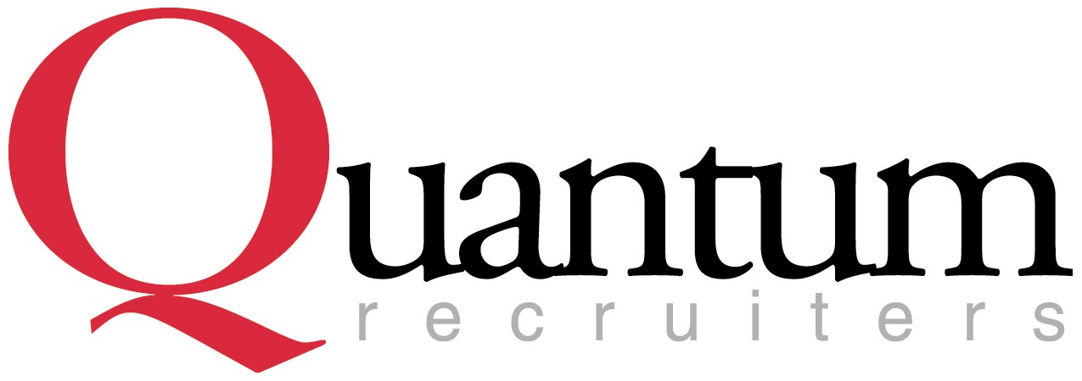

Authorization Agreement
I hereby authorize Quantum Recruiters to obtain a report of my driving record from the Department of Motor Vehicles. I understand that this document shall be kept on file and may be used at any time during my employment to procure an investigative report and that the information obtained may be shared with our clients. I HEARBY WAIVE, RELEASE AND DISCHARGE TO THE MAXIMUM EXTENT PERMITTED BY LAW, QUANTUM RECRUITERS, INC, ITS EMPLOYEES, AND INDIVIDUALS OR AGENCIES OBTAINING INFORMATION FOR QUANTUM RECRUITERS.
I agree to notify Quantum Recruiters immediately if I incur any new driving infractions on my driving record (no matter how minor). I accept full responsibility for any damages that may result from my negligence in operating a motor vehicle if I fail to inform Quantum Recruiters of any changes to my driving record after the initial DMV report is obtained. I hereby understand I will not be authorized to operate any vehicle for the City if I do not have a valid driver's license. This agreement will remain in effect until Quantum Recruiters receives a written notice from me stating I will no longer qualify under this authorization.

Information
Employee Name (please print): ________________________________________________________________

Driver's License # : _____________________________ State: ____________________ CDL: Yes No

Authorized Signature: |  | Date:
Printed Name: |  | Date:

Information

FOR OFFICE USE ONLY

Quantum Representative: Date:

Notes:

Information
8/12

